V.E.S.

LIBRARY MANAGEMENT SYSTEM.

Name: Abhinay Shukla
Roll No: 44

Name: Suraj Yadav
Roll No: 60
INTRODUCTION

Library management system is all about organizing, managing the library and library-oriented tasks. It also involves maintaining the database of entering new books and the record of books that have been retrieved or issued, with their respective dates The main aim of this project is providing an easy to handle and automated library management system. This project also provides features and interface for maintaining librarian’s records, student’s history of issue and fines.
The owner can easily update, delete and insert data in the database with this project.The following are some of the features provided by this project: The issue of books by online mode.Columns provided to search book online .Requests to the librarian can be sent to provide new books in the column. Login portal for a student for security purpose of the library. Homepage for the student which has different buttons to navigate to pages containing the date of issue, date of return, fine charges etc .Columns for teachers to get book issued if desired. Requests column for teachers to ask for the introduction of new or essential books in the library.
Maintaining records of the librarian and other library staff. Feedback page to be viewed and monitored by the college authority, to which student The teacher can mention any misbehave or feedback for the library.

CODE

#include <windows.h>
#include <stdio.h>
#include <string>
#include <mysql.h>
#include <iostream>
#include <sstream>
#include <conio.h>
#include <stdio.h>
#include <ctime>
#include <cstdlib>
using namespace std;

void intro()
{

cout<<"\n\t\t\t*********************************************************************************";
cout<<"\n\t\t * VES Institute Of Technology *";
cout<<"\n\t\t\t*************************************************************************************";
cout<<"\n\t\tMade By: \t Suraj Rama Yadav - 60 ";
cout<<"\n\t\tMade By: \t Abhinay Shukla - 44 ";
cout<<"\t";
cout<<"\n\n\n\t TOPIC: LIBRARY MANAGEMENT SYSTEM";
cout<<"\n\n\n\n\n\n\t\t\t\tPress any key to continue.........";

}
void insertStudent()
{

stringstream ss;
int state = 0;

string name;
string dept;
string divison;
string rollno;
string bookis="0";

cout << "\n\t\t ENTER STUDENT NAME: " ;
cin >> name;
cout << "\n\t\t ENTER STUDENT DEPARTMENT: " ;
cin >> dept;
cout << "\n\t\t ENTER STUDENT DIVISION: " ;
cin >> divison;
cout << "\n\t\t ENTER STUDENT ROLL NUMBER: ";
cin >> rollno;

MYSQL *conn;
MYSQL_ROW row;
MYSQL_RES *res;
conn = mysql_init(0);
conn = mysql_real_connect(conn, "localhost", "root", "", "lib", 0, NULL, 0);
ss << "INSERT INTO student(name,department,division,rollno,bookissue) VALUES('" << name << "','" << dept << "','" << divison << "','" << rollno << "','" << bookis << "')";

string query1 = ss.str();

const char *q1 = query1.c_str();
state = mysql_query(conn, q1);

if (state == 0)
{
cout << "\n\t INSERTED STUDENT \n\n\n"<< endl;
}
else
{
cout << "\n\t CAN NOT INSERT \n\n\n" << endl
<< mysql_error(conn) << endl;
}

}

void fetchStudent()
{
string temp;
stringstream ss1;
string id;

cout<<"\n\t SEARCH STUDENT DEATILS\n\n"<<endl;
cout << "ENTER STUDENT ID : ";
cin >> id;

MYSQL *conn;
MYSQL_ROW row;
MYSQL_RES *res;
conn = mysql_init(0);
conn = mysql_real_connect(conn, "localhost", "root", "", "lib", 0, NULL, 0);

ss1 << "select id from student where id='" << id << "'";
string query = ss1.str();
const char *q = query.c_str();
int state = mysql_query(conn, q);
if (!state)
{
res = mysql_store_result(conn);
while (row = mysql_fetch_row(res))
{
temp = row[0];
}
}
if (id == temp)
{
stringstream ss;
cout<<endl;

MYSQL *conn;
MYSQL_ROW row;
MYSQL_RES *res;
conn = mysql_init(0);
conn = mysql_real_connect(conn, "localhost", "root", "", "lib", 0, NULL, 0);

ss << "select * from student where id='" << id << "'";
string query = ss.str();
const char *q = query.c_str();
int state = mysql_query(conn, q);

if (!state)
{
res = mysql_store_result(conn);
while (row = mysql_fetch_row(res))
{
cout << "\n\n\t ID : " << row[0] << " " << endl
<< "\n\n\t NAME : " << row[1] << " " << endl
<< "\n\n\t DEPARTMENT : " << row[2] << " " << endl
<< "\n\n\t DIVISION : " << row[3] << " " << endl
<< "\n\n\t ROLL NUMBER : " << row[4] << " " << endl
<< "\n\n\t NO OF ISSUE BOOK : " << row[5] << " " << endl;

}
}
else{
cout<<"\n\t USER IS NOT FOUND";
}

}
else
{
cout << "\n\t ID DOES NOT EXIST"<<endl;
}
}

void updateStudent()
{

string temp;
stringstream ss;
string id;

cout<<"\n\t UPDATE STUDENT DEATILS\n\n"<<endl;
cout << "\n\n\t ENTER STUDENT ID : ";
cin >> id;

MYSQL *conn;
MYSQL_ROW row;
MYSQL_RES *res;
conn = mysql_init(0);
conn = mysql_real_connect(conn, "localhost", "root", "", "lib", 0, NULL, 0);

ss << "select id from student where id='" << id << "'";
string query = ss.str();
const char *q = query.c_str();
int state = mysql_query(conn, q);
if (!state)
{
res = mysql_store_result(conn);
while (row = mysql_fetch_row(res))
{
temp = row[0];
}
}
if (id == temp)
{
int state = 0;
stringstream ss;
string name;
string dept;
string divison;
string rollno;
string bookis="0";

cout << "\n\t\t ENTER STUDENT NAME: " ;
cin >> name;
cout << "\n\t\t ENTER STUDENT DEPARTMENT: " ;
cin >> dept;
cout << "\n\t\t ENTER STUDENT DIVISION: " ;
cin >> divison;
cout << "\n\t\t ENTER STUDENT ROLL NUMBER: ";
cin >> rollno;

MYSQL *conn;
MYSQL_ROW row;
MYSQL_RES *res;
conn = mysql_init(0);
conn = mysql_real_connect(conn, "localhost", "root", "", "lib", 0, NULL, 0);

ss << "update student set name='" << name << "',department='" << dept << "',division='" << divison << "',rollno='" << rollno << "',bookissue='" << bookis << "' where id='" << id << "'";
string query = ss.str();
const char *q = query.c_str();
state = mysql_query(conn, q);

cout<<endl<<state;

if (state == 0)
{
cout << "\n\t UPDATE STUDENT DATA OF ID : "<< id;
/*if (!state)
{
res = mysql_store_result(conn);
while (row = mysql_fetch_row(res))
{
cout << "Student id/Roll No.:" << row[0]<< endl
<< "ITM:" << row[1] << " " << endl
<< "COA:" << row[2] << " " << endl
<< "OOPS:" << row[3] << " " << endl
<< "SEPM:" << row[4] << " " << endl
<< "MATHS:" << row[5] << endl;
}
}
else
{
cout << mysql_error(conn);
}
*/
}
else
{
cout << "\n\t CAN NOT UPDATE, SOME DATABASE PROBLEM"<<endl;
}
}
else
{
cout << "\n\t ID DOES NOT EXIST"<<endl;
}
}

void deleteStudent()
{
//cout << "inside delete";
string temp;
stringstream ss;
string id;
cout<<"\n\t DELETE STUDENT INFORMATION\n\n"<<endl;
cout << "\n\n\t ENTER STUDENT ID : ";
cin >> id;

MYSQL *conn;
MYSQL_ROW row;
MYSQL_RES *res;
conn = mysql_init(0);
conn = mysql_real_connect(conn, "localhost", "root", "", "lib", 0, NULL, 0);

ss << "select id from student where id='" << id << "'";
string query = ss.str();
const char *q = query.c_str();
int state = mysql_query(conn, q);
if (!state)
{
res = mysql_store_result(conn);
while (row = mysql_fetch_row(res))
{
temp = row[0];
}
}
if (id == temp)
{
//cout << "id: " << id << endl;
//cout << "temp: " << temp << endl;
//cout << "id matched" << endl;
stringstream ss1;
int state = 0;
MYSQL *conn;
MYSQL_ROW row;
MYSQL_RES *res;
conn = mysql_init(0);
conn = mysql_real_connect(conn, "localhost", "root", "", "lib", 0, NULL, 0);
ss1 << "delete from student where id='" << id << "'";
//cout << "id: " << id << endl;
string query1 = ss1.str();
//cout << "q1 : " << query1 << endl;
const char *q1 = query1.c_str();
state = mysql_query(conn, q1);
//cout << "state: " << state;
if (state == 0)
{
cout << "\n\t DELETED STUDENT ID : "<<id<< endl;
}
else
{
cout << mysql_error(conn) << endl;
}
}
else
{
cout << "\n\t STUDENT NOT EVEN EXIST\n\n"<<endl;
}
}

class lib{

public:void login()
{
intro();
getch();

START:
system("CLS");
cout << "\n\n\n\n\n\n\n\n\t\t\t\t\t\tADMIN LOGIN";
string un;
char pass[32];
int i = 0;
char a;
cout << "\n\n\n\t\t\t\t\tENTER USERNAME : ";
cin >> un;
cout << "\n\n\t\t\t\t\tENTER PASSWORD : ";
for (i = 0;;)
{
a = getch();
if ((a >= 'a' && a <= 'z') || (a >= 'A' && a <= 'Z') || (a >= '0' && a <= '9'))
{
pass[i] = a;
++i;
cout << "*";
}
if (a == '\b' && i >= 1)
{
cout << "\b \b";
--i;
}
if (a == '\r')
{
pass[i] = '\0';
break;
}
}
if (i <= 4)
{
cout << "\n\n\n\t\t\t\t\tnminimum 4 digit needed";
goto START;
}
std::string s(pass);

if (un == "admin" && s == "12345")
{
system("CLS");
user();
}
else
{
cout << "\n\n\n\t\t\t\t\tINCORRECT USERNAME OR PASSWORD";
cout << "\n\n\n\t\t\t\t\tPress Any Key To Login Again........";
getch();
system("CLS");
goto START;
}
}
public: void user(){

system("CLS");
int ch;

cout<<"\n\n\n\tMAIN MENU";
cout<<"\n\n\t1.ISSUE A BOOK";
cout<<"\n\n\t2.RETURN A BOOK";
cout<<"\n\n\t3.DISPLAY ALL BOOK";
cout<<"\n\n\t4.DISPLAY SPECIFIC ISSUE BOOK";
cout<<"\n\n\t5.DISPLAY SPECIFIC STUDENT RECORD ";
cout<<"\n\n\t6.ADMINISTRATOR MENU";
cout<<"\n\n\t7.EXIT MENU";

cout<<"\n\n\tPlease Enter Your Choice (1-4) ";
cin>>ch;
switch(ch)
{

case 1:system("CLS");
booking();
user();
break;
case 2:system("CLS");
returnbook();
user();
break;
case 3:system("CLS");

allbooks();
getch();
user();
break;
case 4:system("CLS");

showbooking();
getch();
user();
break;
case 5:system("CLS");
fetchStudent();
getch();
user();

break;
case 6:
system("CLS");
menu();
case 7:
exit(0);
default:cout<<"\nInvalid Choice\nTRY AGAIN\n";
}

}

public: void menu()
{
int ch2;
cout<<"\n\n\n\tADMINISTRATOR MENU";
cout<<"\n\n\t1.CREATE STUDENT RECORD";
cout<<"\n\n\t2.DISPLAY ALL STUDENTS RECORD";
cout<<"\n\n\t3.DISPLAY SPECIFIC STUDENT RECORD ";
cout<<"\n\n\t4.MODIFY STUDENT RECORD";
cout<<"\n\n\t5.DELETE STUDENT RECORD";
cout<<"\n\n\t6.CREATE BOOK ";
cout<<"\n\n\t7.DISPLAY ALL BOOKS ";
cout<<"\n\n\t8.DISPLAY SPECIFIC BOOK ";
cout<<"\n\n\t9.MODIFY BOOK ";
cout<<"\n\n\t10.DELETE BOOK ";
cout<<"\n\n\t11.DISPLAY ALL ISSUE BOOK ";
cout<<"\n\n\t12.REPORT ";
cout<<"\n\n\t13.BACK TO MAIN MENU";
cout<<"\n\n\tPlease Enter Your Choice (1-11) ";
cin>>ch2;
switch(ch2)
{
case 1:system("CLS");
insertStudent();
getch();
menu();
break;
case 2:system("CLS");

allstudent();
getch();
menu();

break;
case 3:system("CLS");
fetchStudent();
getch();
menu();

break;
case 4: system("CLS");
updateStudent();
getch();

menu();
break;
case 5:system("CLS");
deleteStudent();

getch();
menu();
break;
case 6:system("CLS");
insertbook();
getch();
menu();
break;
case 7:system("CLS");
allbooks();
getch();
menu();
break;
case 8:system("CLS");
fetchbook();
getch();

menu();
break;
case 9: system("CLS");
updatebook();
getch();

menu();
break;
case 10:system("CLS");
deletebook();
getch();

menu();
break;
case 11:system("CLS");
allbooking();
getch();

menu();
break;
case 12:system("CLS");

report();
getch();

menu();
break;
case 13:system("CLS");
user();

break;

default:cout<<"\nInvalid Choice\nTRY AGAIN\n";

}

}

};

int main()
{

lib obj;
obj.login();

return 0;
}
OUTPUT :
INTRODUCTION

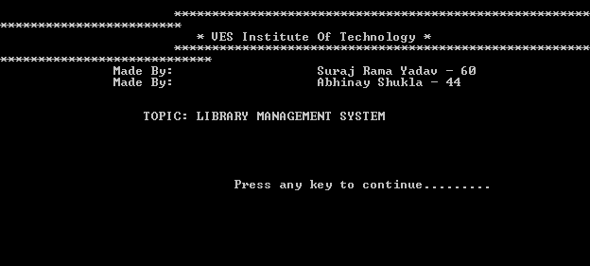
LOGIN
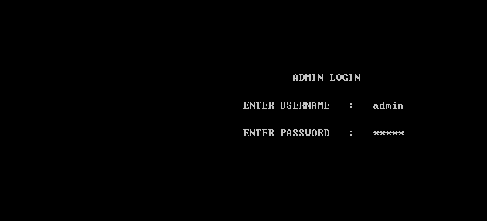

MENU
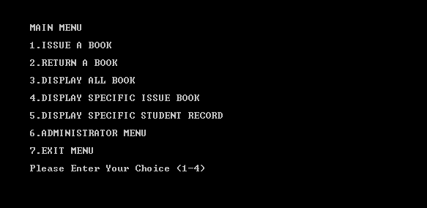
ADMIN MENU
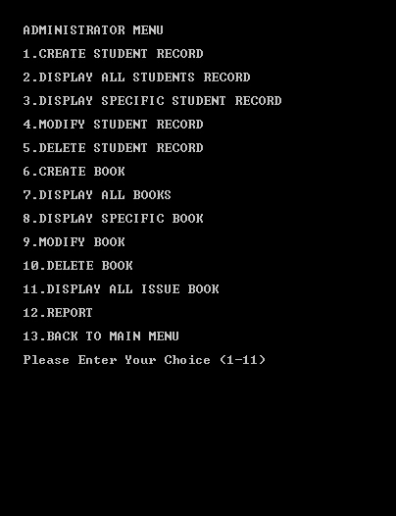

ISSUE BOOK
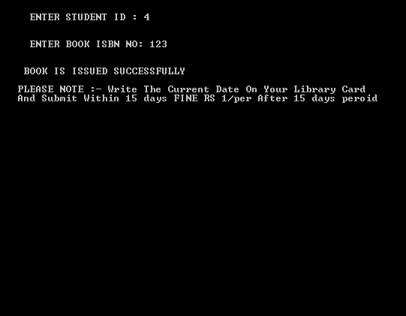
Return book
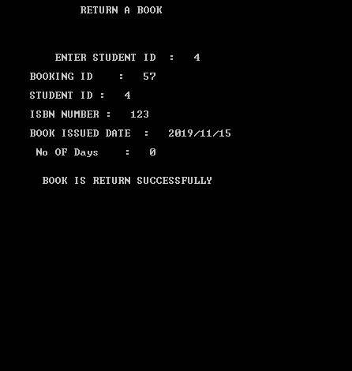

All BOOK
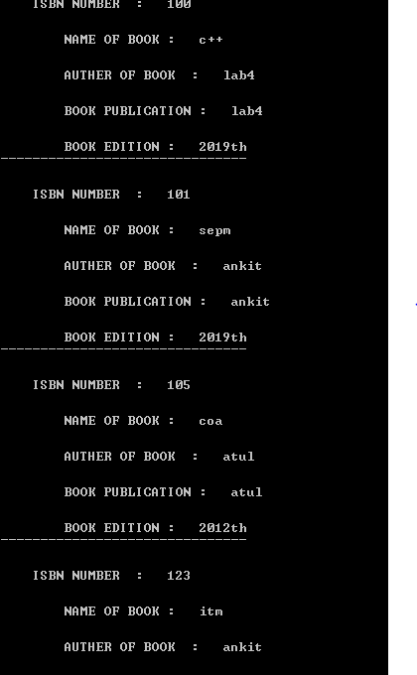

Student Search
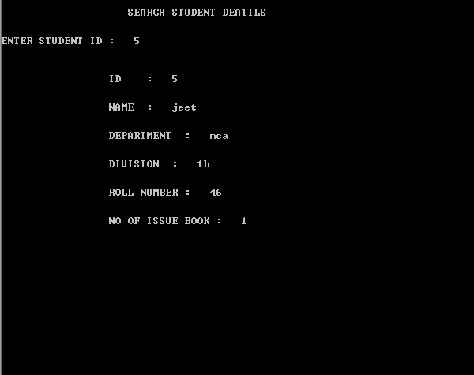

DATABASE

Student table
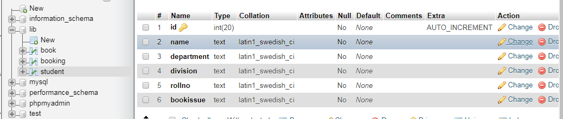

Book table
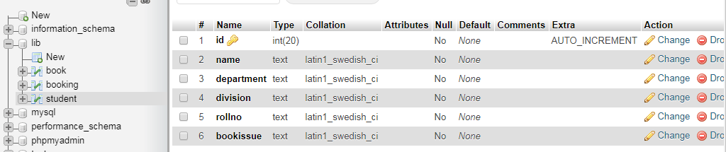
booking Table
